University Of Engineering and Technology, Lahore
Computer Engineering Department

Course Name: Programming Fundamentals | Course Code: CMPE-112L
Assignment Type: Lab tasks | Dated: 16 Feb 2026
Semester: First | Session: 2026 Spring
Lab/Project/Assignment #: 1 | CLOs to be covered: CLO 1
Lab Title: Input/Output, Data Types, Operators, Conditional Statements (If/Else) | Teacher Name: Hafiz Muhammad Mubashar
Lab Evaluation:

CLO1 | Apply appropriate programming techniques to create executable programs to solve well defined problems
CLO1 | Level1 | Level2 | Level3 | Level4 | Level5 | Level6
(5)
Total |  |  |  |  |  | /5
Rubrics for Current Lab Evaluation
Scale | Marks | Level | Rubric
Excellent | 5 | L1 | Submitted all lab tasks, BONUS task, have good understanding.
Very Good | 4 | L2 | Submitted the lab tasks but have good understanding
Good | 3 | L3 | Submitted the lab tasks but have weak understanding.
Basic | 2 | L4 | Submitted the lab tasks but have no understanding.
Barely Acceptable | 1 | L5 | Submitted only one lab task.
Not Acceptable | 0 | L6 | Did not attempt
Week 1 LAB
Input/Output, Data Types, Operators, Conditional Statements (If/Else)
Lab Goals/Objectives:
* Learn Python syntax.
* Take user input and display output.
* Understand data types and operators.
* Implement decision making using if/else.
Equipment Required:

* Computer/Laptop
* Python 3.14
* VS Code or pycharm

Theory:
Python provides the input() function for taking input and print() for displaying output. Variables store different data types such as integers, floats, strings, and booleans. Operators perform arithmetic, logical, and comparison operations. Conditional statements (if, elif, else) execute different blocks based on conditions.

Lab Work:

Task 1: Initializes basic variables with specific values and prints them out.
name = "Bilal"
roll_no = 86
age = 20

Result:

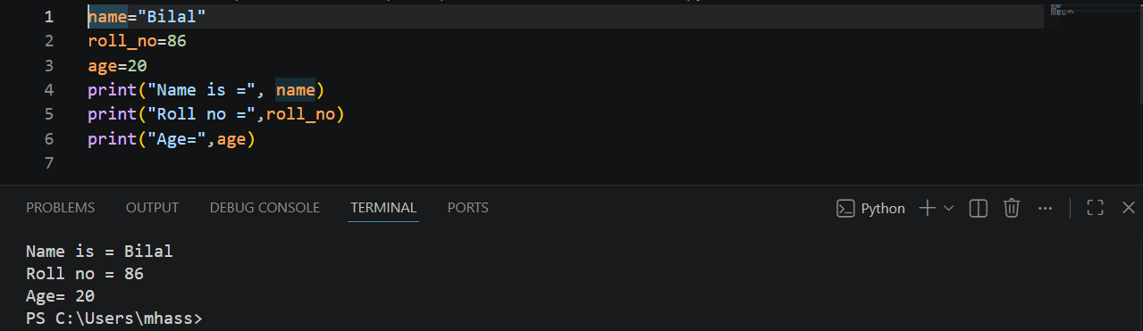

Task 2: This task collects a user's name, roll number, and age dynamically via console inputs and displays them.
a=input("Enter your name=")
b=input("Enter your Roll no=")
c=input("Enter your age=")

Result:
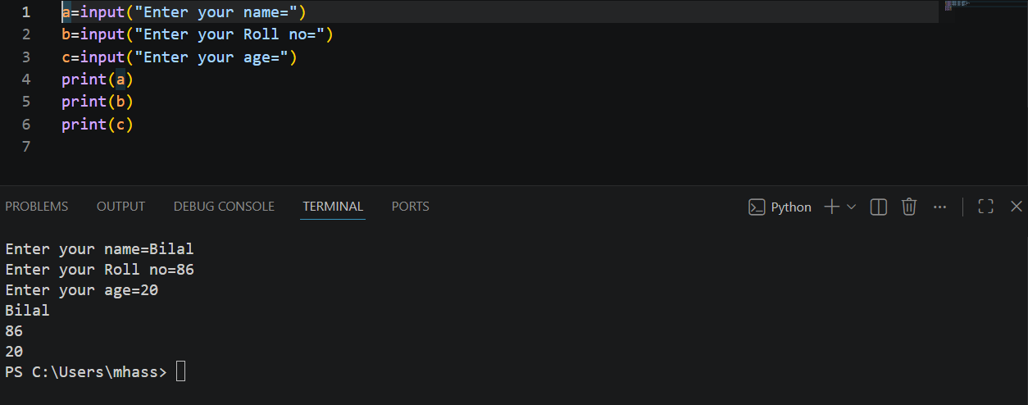

Task 3: Adds two integers together and outputs the result.
a=10
b=12
sum=a+b

Result:
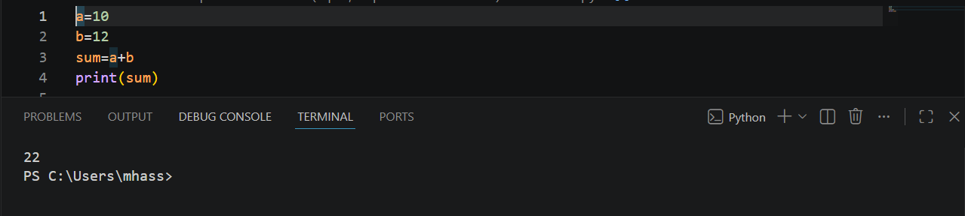

Task 4: Type casting by converting string digits into integers before adding them.
a=int("1")
b=int("2")
sum=a+b

Result:

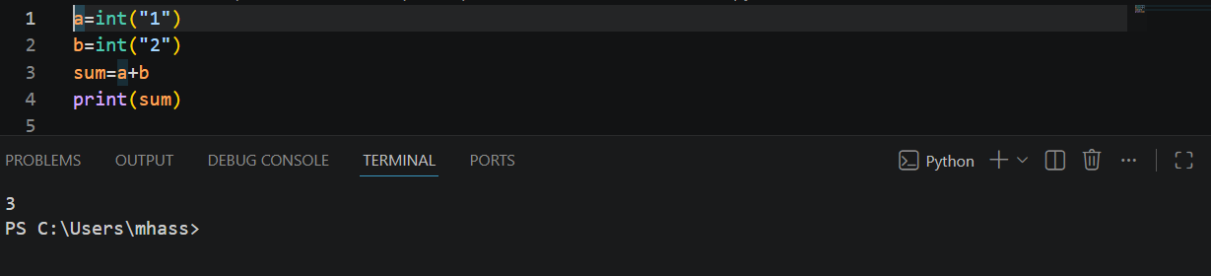

Task 5: Combines user input with integer casting to calculate the sum of two numbers provided by the user.
a=int(input("Enter first number"))
b=int(input("Enter Second number"))
sum=a+b
Result:

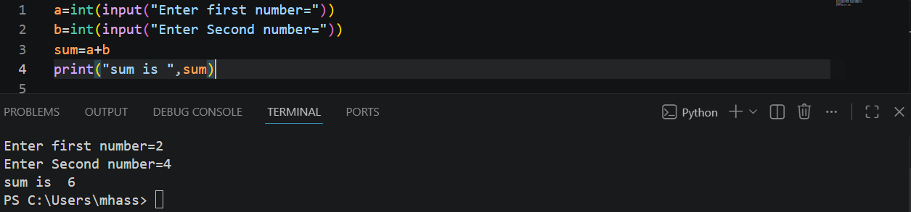

Task 6: Calculates the percentage based on user-inputted obtained and total marks.
per=(a/b)*100

Result:

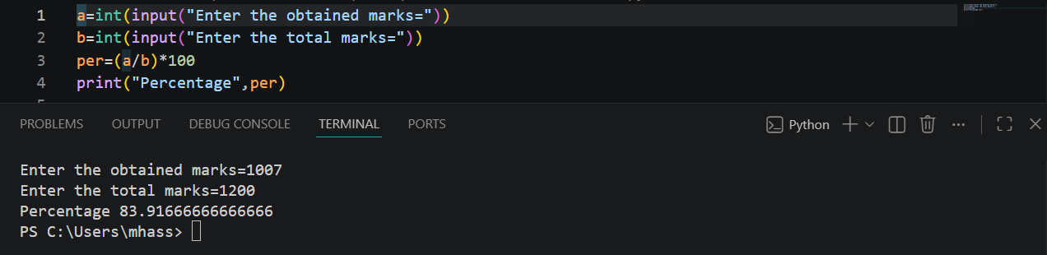

Task 7: Extends the percentage calculator by using conditional logic (if-elif-else) to assign a letter grade.

if(per>=90):
print("Grade A")

elif(per>=85):
print("Grade A-")

elif(per>=80):
print("Grade B+")

elif(per>=75):
print("Grade B-")

elif(per>=70):
print("Grade C")

else :
print("Fail")

Result:
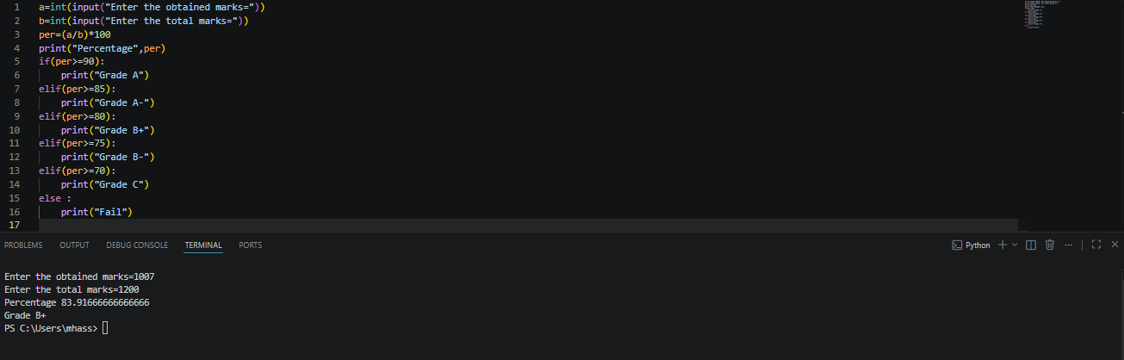

Task 8: Uses a for loop to calculate percentages and grades for a fixed, user-defined number of students.

c=int(input("Enter the total Students numbers="))
for i in range(c):
if(per>=90):
g="A"
elif(per>=85):
g="A-"
elif(per>=80):
g="B+"
elif(per>=75):
g="B-"
elif(per>=70):
g="C"
else :
g="F"

Result:

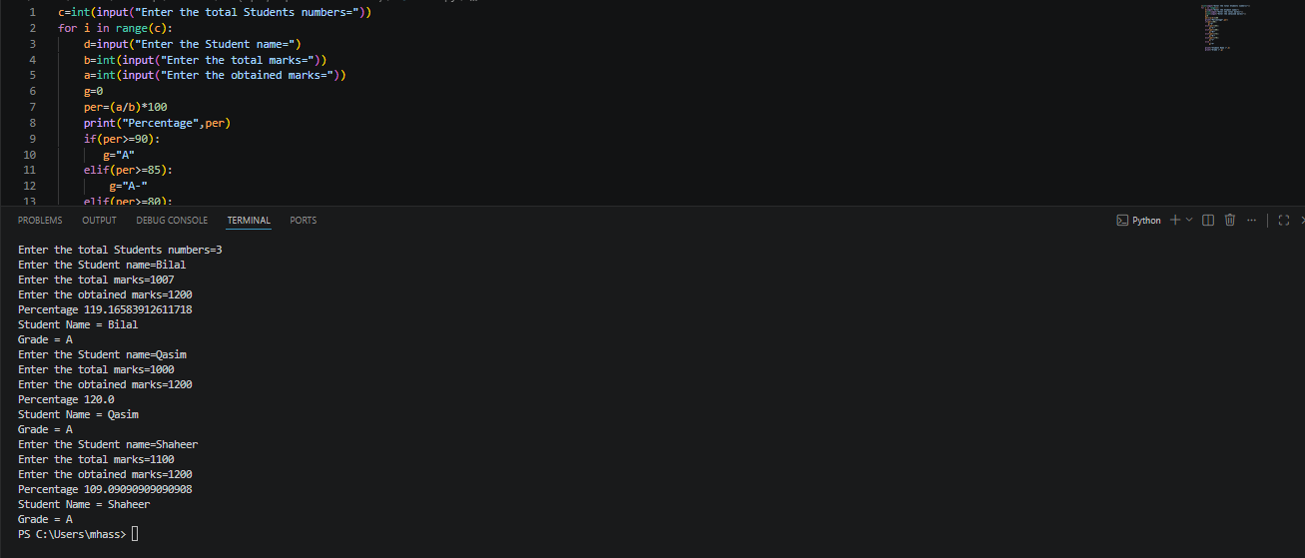

Task 9: Achieves the same multi-student grading functionality as Task 8, but implements a while loop control structure instead.

i=1
c=int(input("Enter the total Students numbers="))
while (i<=c):
###if elif conditions for Grading
Result:

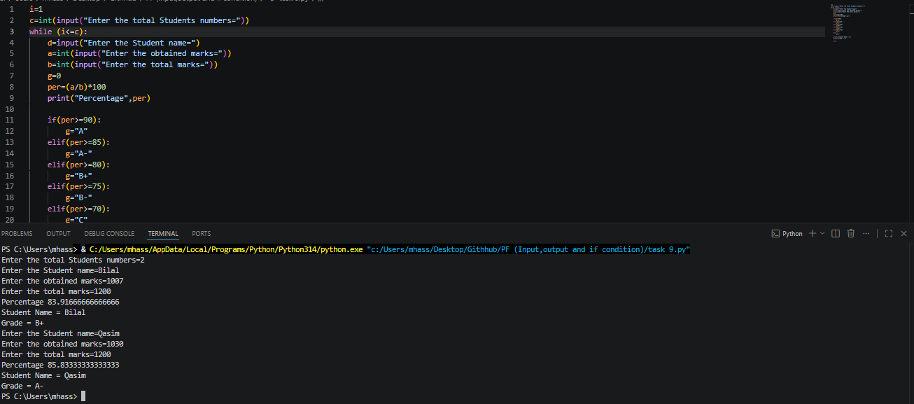

Task 10: Analyzes a raw text input to determine and cast it into its most appropriate data type (float, int, or default str).
if "." in a:
a=float(a)
elif a.isdigit():
a=int(a)

Result:

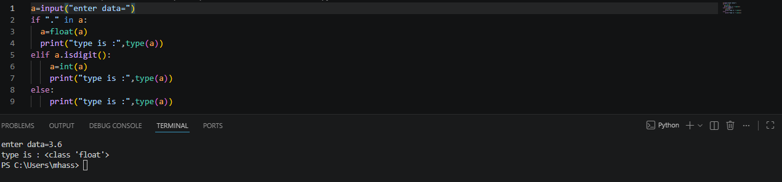

Task 12: Print integer as float.
print (float("5"))

Result:
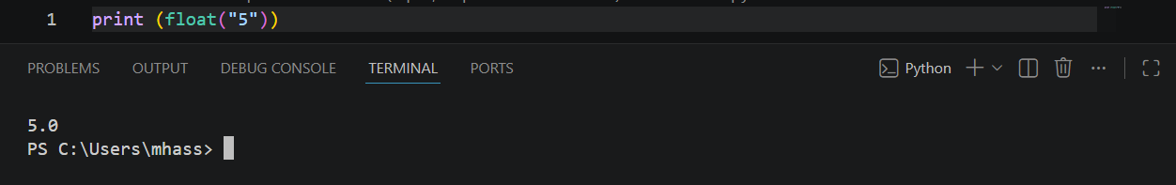

Task 13: Print the length of string.
a = len("Muhammad Bilal")

Result:
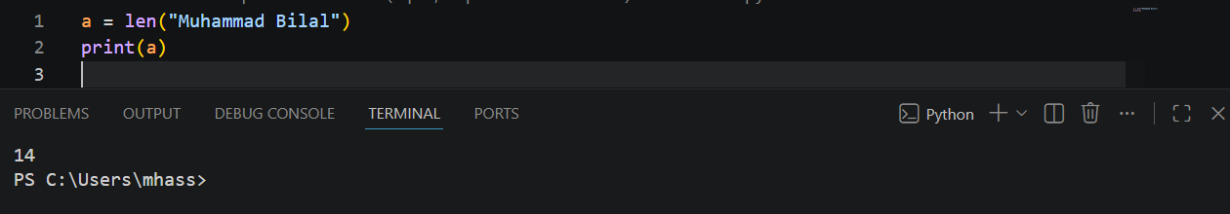

Conclusions:
These exercises show how to take raw data, convert it accurately, apply logical conditions, and automate the entire workflow to build responsive and efficient scripts.

